THE UNIVERSITY OF LAHORE
CS-4349 Software Testing & Implementation

Assignment-1

Due Date: (10-MAY -2016)

Exercise-1:

As a software tester, what do you do? Of course, testing the software, you would say………Okay, can you find out defects on the page shown below?
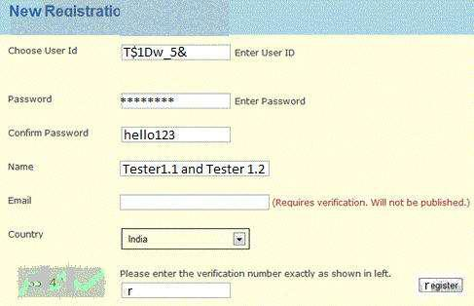

Here is how you can judge yourself:
If you find:
0 – 4 defects => Poor

5 – 6 defects => Average
7 – 8 defects => Good
9 – 10 defects => Excellent
10+ defects => Best tester!

(Mind well, you are the judge and you need to count on valid defects)
Exercise-2:

Write test ideas for this Scenario: You are at Grocery store’s checkout counter. You have bought five items (x, y, z, a, and b). You make payment and move to EXIT door.

Exercise-3:

Providing suggestion to improve quality or user experience is the extension of software testing job. So why not try that? Can you tell us how user experience can be improved for following sign in page?
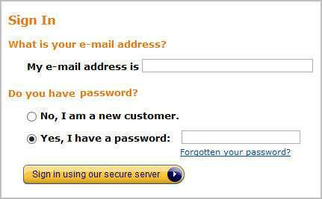

Exercise-4: Role of an End User

As a tester, we do not test the application product. We do play a role of an end user. We do try to generate real time scenarios where the end user might not behave the way they are expected…..how the product would respond, that is what we test.

Let’s reverse the process to a small degree –

As an end user how would you like to modify the ATM (Automated Teller Machine) so that it can be more beneficial? Don’t provide just ideas, provide relevant reasons too.
EXERCISE-5

There is a simple program with the following items:

- Input Box A

- Input Box B
- Add button

- Result Text Box [=A+B]

Identify all the test cases for the program. [Example: press the Add button without entering anything in Input Box A and B]

EXERCISE-6

Calculator (Static Image simulating bugs)
Test Execution / Find Bugs

How many bugs can you find on this buggy windows calculator? Bug Count: Over 5
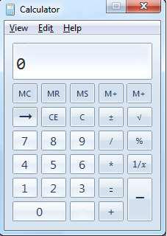
EXERCISE-7

Login feature Design mock-up

Test Analysis & Design

Derive Test Scenarios for the Login feature by using design mockup. Apply design techniques for adequate test coverage. NOTE: Business requirements are not documented, so ensure you have covered all the relevant / standard authentication test conditions.
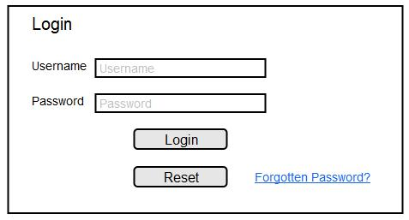

EXERCISE-8

Find more than 20 defects (layout inconsistencies, spelling errors, and the like) in the image below:

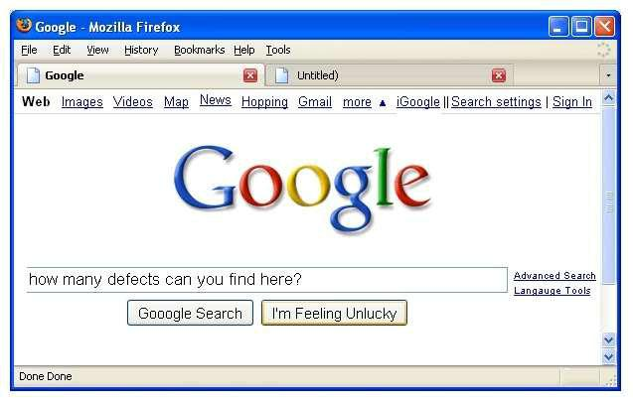

Exercise 9:
Answer the following

Q. 1: An input field takes the year of birth between 1900 and 2004
The boundary values for testing this field are
A. 0,1900,2004,2005
B. 1900, 2004
C. 1899,1900,2004,2005
D. 1899, 1900, 1901,2003,2004,2005

Q. 2: One of the fields on a form contains a text box which accepts numeric values in the range of 18 to 25. Identify the invalid Equivalance class
A. 17
B. 19
C. 24
D. 21

Q. 3: In a Examination a candidate has to score minimum of 24 marks inorder to clear the exam. The maximum that he can score is 40 marks. Identify the Valid Equivalance values if the student clears the exam.
A. 22,23,26
B. 21,39,40
C. 29,30,31
D. 0,15,22

Q. 4: One of the fields on a form contains a text box which accepts alpha numeric values. Identify the Valid Equivalence class
A. BOOK
B. Book
C. Boo01k
D. book

Q. 5: The Switch is switched off once the temperature falls below 18 and then it is turned on when the temperature is more than 21. When the temperature is more than 21. Identify the Equivalance values which belong to the same class.
A. 12,16,22
B. 24,27,17
C. 22,23,24
D. 14,15,19

Q. 6: ‘X’ has given a data on a person age, which should be between 1 to 99. Using BVA which is the appropriate one
A. 0,1,2,99
B. 1, 99, 100, 98
C. 0, 1, 99, 100
D. –1, 0, 1, 99

Q. 7: A wholesaler sells printer cartridges. The minimum order quantity is 5. There is a 20% discount for orders of 100 or more printer cartridges. You have been asked to prepare test cases using various values for the number of printer cartridges ordered. Which of the following groups contain three test inputs that would be generated using Boundary Value Analysis?
A. 5, 6, 20
B. 4, 5, 80
C. 4, 5, 99
D. 1, 20, 100

Q. 8: A thermometer measures temperature in whole degrees only. If the temperature falls below 18 degrees, the heating is switched off. It is switched on again when the temperature reaches 21 degrees. What are the best values in degrees to cover all equivalence partitions?
A. 15,19 and 25.
B. 17,18 and19.
C. 18, 20 and22.
D. 16, 26 and 32.

Q. 9: Assume postal rates for 'light letters' are:
$0.25 up to 10 grams;
$0.35 up to 50 grams;
$0.45 up to 75 grams;
$0.55 up to 100 grams.
Which test inputs (in grams) would be selected using boundary value analysis?
A. 0, 9,19, 49, 50, 74, 75, 99,100
B. 10, 50, 75,100, 250, 1000
C. 0, 1,10,11, 50, 51, 75, 76,100,101
D. 25, 26, 35, 36, 45, 46, 55, 56

Q. 10: If the temperature falls below 18 degrees, the heating is switched on. When the temperature reaches 21 degrees, the heating is switched off. What is the minimum set of test input values to cover all valid equivalence partitions?
A. 15, 19 and 25 degrees
B. 17, 18, 20 and 21 degrees
C. 18, 20 and 22 degrees
D. 16 and 26 degrees

Q. 11: In a system designed to work out the tax to be paid:
An employee has £4000 of salary tax free.
The next £1500 is taxed at 10%.
The next £28000 after that is taxed at 22%.
Any further amount is taxed at 40%.
To the nearest whole pound, which of these is a valid Boundary Value Analysis test case?
A. £28000.
B. £33501.
C. £32001.
D. £1500.

Q. 13: Given the following specification, which of the following values for age are in
the SAME equivalence partition?
If you are less than 18, you are too young to be insured. Between 18 and 30 inclusive, you
will receive a 20% discount. Anyone over 30 is not eligible for a discount.
A. 17, 18, 19.
B. 29, 30, 31.
C. 18, 29, 30.
D. 17, 29, 31.

